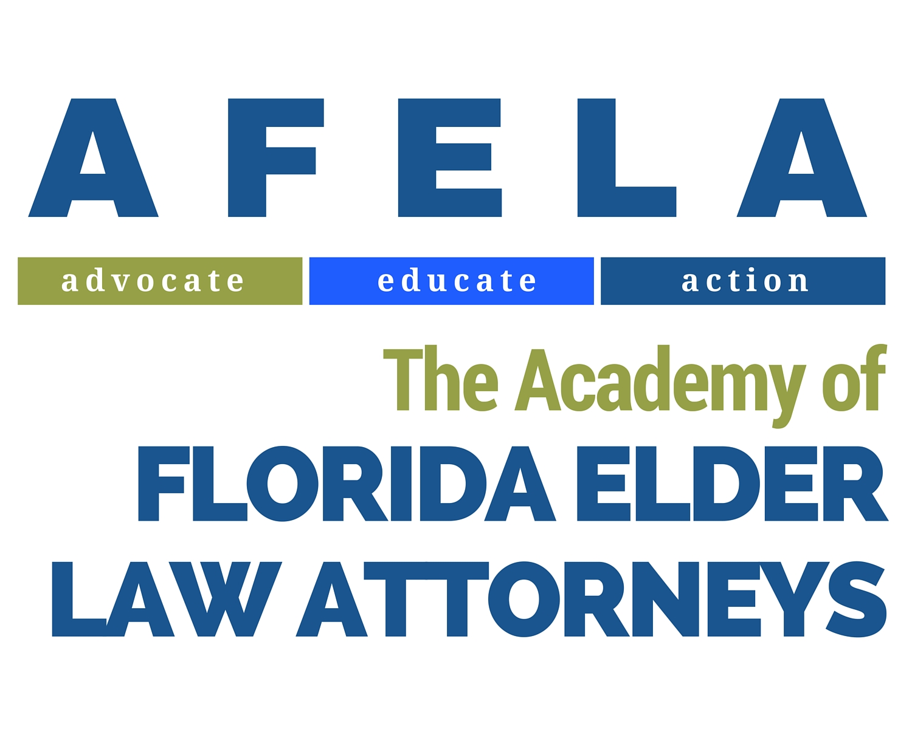
JEROME SOLKOFF ADVOCACY AWARD
The Jerome Solkoff Advocacy Award is an annual advocacy award presented by The Academy of Florida Elder Law Attorneys (AFELA) to an AFELA member or member of an Elder Allied Organization in recognition of his or her advocacy and support of our state’s elderly and disabled citizens.
_________________________________________________________________
Jerome “Jerry” Solkoff was a lifelong advocate for the elderly and disabled. He enjoyed a distinguished professional life spanning more than four decades. Jerry received numerous honors for his advocacy on behalf of the elderly during his lifetime and amassed thousands of hours of pro bono services within his community.
_________________________________________________________________

Application Process
- Nomination forms will be accepted via mail or email as follows:
Academy of Florida Elder Law Attorneys (AFELA)
c/o Jennifer Dooley, Executive Director for AFELA
3380 Barrow Hill Trail
Tallahassee, FL 32312
www.afela.org
- Third Party submissions (no self-nominations accepted) shall be received no later than August 31, 2017.
- All nominations will be considered by the AFELA board at the September 2017 board meeting.
- Honoree will be recognized at the December AFELA UnProgram.

NOMINATION FORM
JEROME SOLKOFF ADVOCACY AWARD

- Name of Nominee for Consideration:

- Submitted by (Name and Organization, if applicable):

- Contact Information (Address, Email and Phone Number):

- Please describe the nominee’s participation in activities, organizations, committees in support of our state’s elderly and disabled citizens:

- Please describe nominee’s overall advocacy work in the past 5 years:

- Please describe, in your opinion, the most significant advocacy effort the nominee engaged in and the result achieved or impact made:

